# Specification

The specification is presented in several parts. In this document is given a series of screen shots and textual descriptions for visual reference.

A demonstration video is also presented on Canvas. This demonstration video is considered part of the specification and contains important details about the dynamic function of the assignment.

# Menus

There are two menu layers in the application. The main menu (AssociationView.fxml) has two sub-menus, the team menu (ExploreTeamsView.fxml) and the season menu (SeasonView.fxml). The main menu and the team menu share the same layout but have different functions.

The main menu is opened when the application launches. It has “Explore the teams” button to access the team menu and “Arrange a new season” button to access the season menu. It also has an exit button which shuts the entire application down. The main menu has a header section with a logo “PLAYOFFS”. The title of the window includes an “NBA” icon and the tile “NBAfx View”.

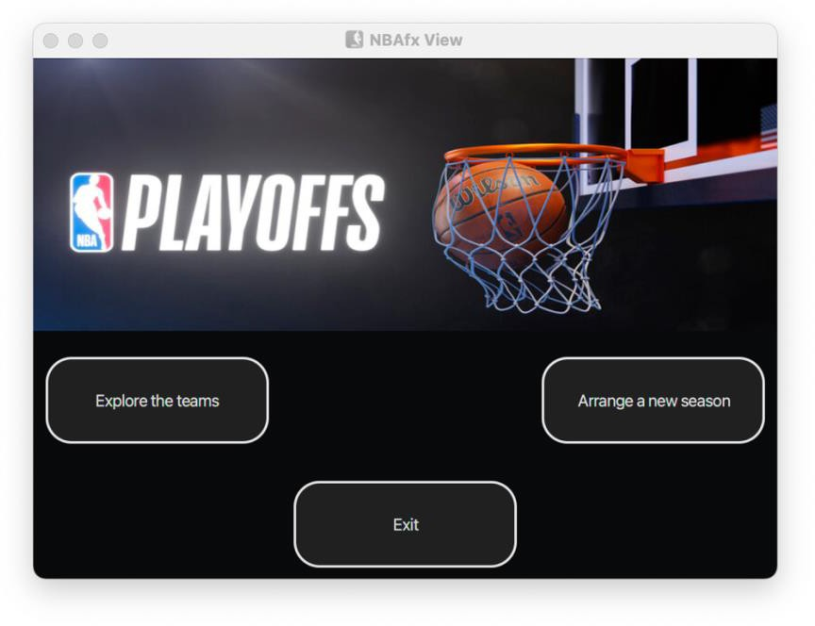

The team menu is launched from the main menu by opening a separate window. It has “Teams Menu” button to access the teams table window (TeamsTable.fxml) and “ViewPlayers” button to access the players window (PlayersView.fxml). It has an “Close” button to close the current stage. The team menu also has a header section with a logo “PLAYOFFS”. The title of the window includes an “NBA” icon and the tile “Explore Teams”.

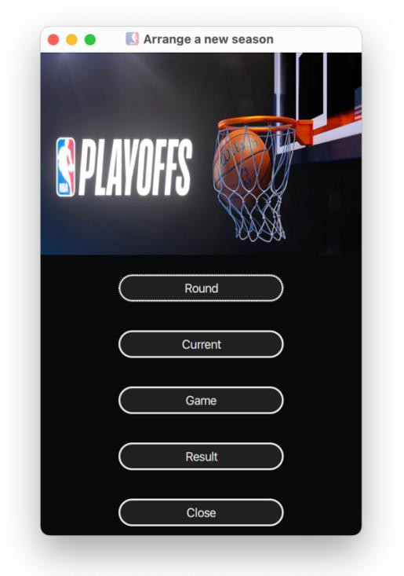

The season menu is launched from the main menu by opening a separate window. It has “Round” button to access the season round window (SeasonRoundView.fxml) and “Current” button to access the current round teams window (CurrentRoundTeam.fxml). It has “Game” button to run the tournament and “Result” button to display the record window (RecordView.fxml). It has an “Close” button to close the current stage. The season menu also has a header section with a logo “PLAYOFFS”. The title of the window includes an “NBA” icon and the tile “Arrange a new season”.

# Teams Table Window

The team table window (TeamsTable.fxml) is launched from the team menu by opening a separate window. The team table window displays the teams’ information by a table with 4 columns “Team Name”, “Number of Players”, “Average Player Credit” and “Average Age”. The team table window has four buttons to add, manage or delete a team. Only "Add" and "Close" buttons are enabled initially.

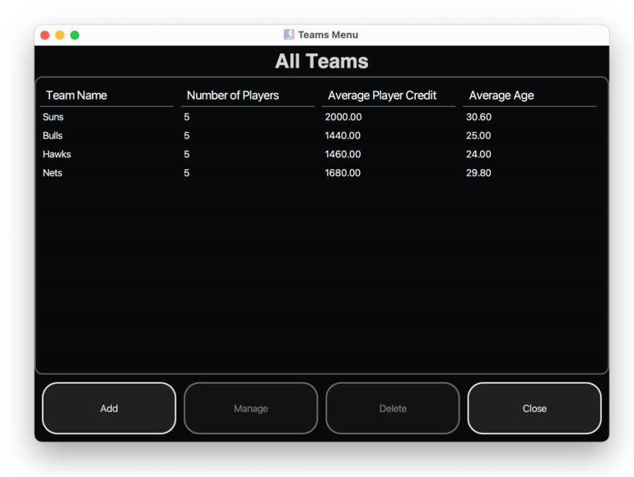

When click on “Add” button, a new window with title “Adding New Team” (AddTeam.fxml) is launched. A new team will be added to the team table window after input a new team’s name. The new team’s average credit and average age are 00.00 as the number of players is 0. If input an existing team’s name, an error window will pop up with the message” (*Name)* Team already exists”. Details of the Error message window will be explained in the later session.

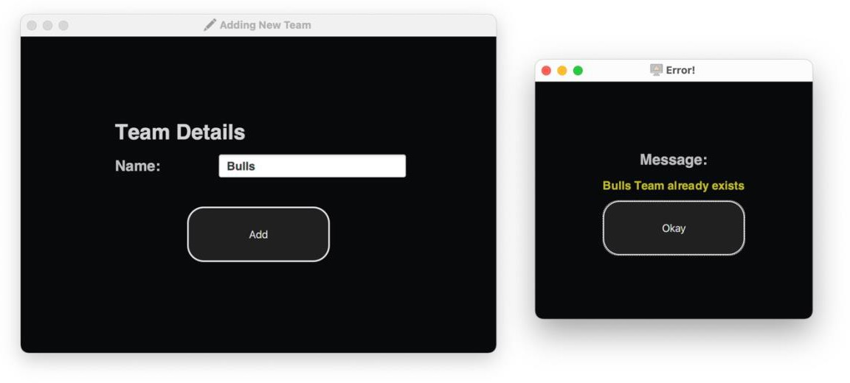

When click on one team record in the table, the selected record is highlighted and the “Manage” and “Delete” buttons are enabled. Meanwhile, “Add” button is disabled. Click the “Delete” button will remove the selected team from the table. The “Manage” and “Delete” buttons will become disabled after the removal.

The Close button closes the teams table window. The teams table window includes an “NBA” icon. The title of the window is “Teams Menu”.

# Manage a Team

The team manage window (ManageTeamView.fxml) is launched from the “Manage” button in the team table window by opening a separate window. The team manage window displays the teams’ players information by a table with 4 columns “Player Name”, “Player credit”, “Player Age” and “Player No”. The team manage window has four buttons to add, update or delete a player. Only "Add" and "Save and Close" buttons are enabled initially.

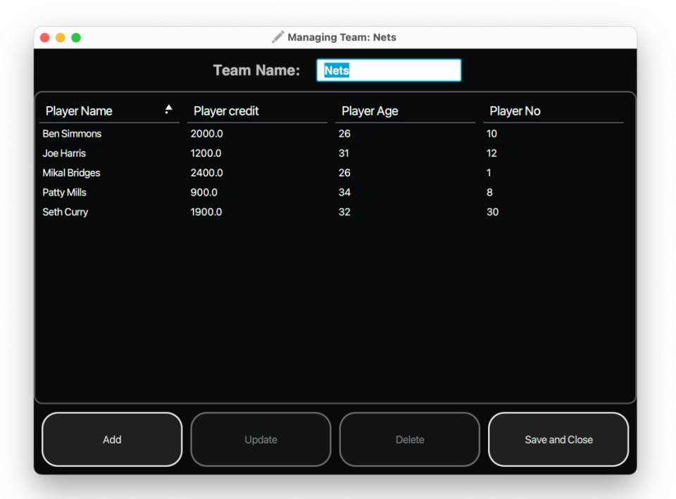

The team’s name is displayed in a text field on the top of the window, where the team’s name can be

updated while clicking “Save and Close” button.

When click on one player record in the table, the selected record is highlighted and the “Update” and “Delete” buttons are enabled. Meanwhile, “Add” button is disabled. Click the “Delete” button will remove the selected player from the table. The “Update” and “Delete” buttons will become disabled after the removal. The “Add” button will become enabled after the removal.

The Save and Close button closes the team manage window. The team manage window includes an “edit” icon. The title of the window is “Managing Team:” plus the team’s name.

# Player Update Window

The player update window (PlayerUpdateView.fxml) is launched from the team manage window by clicking “Update” for a player’s record. The player update window displays the information of “Player Details” for an existing player.

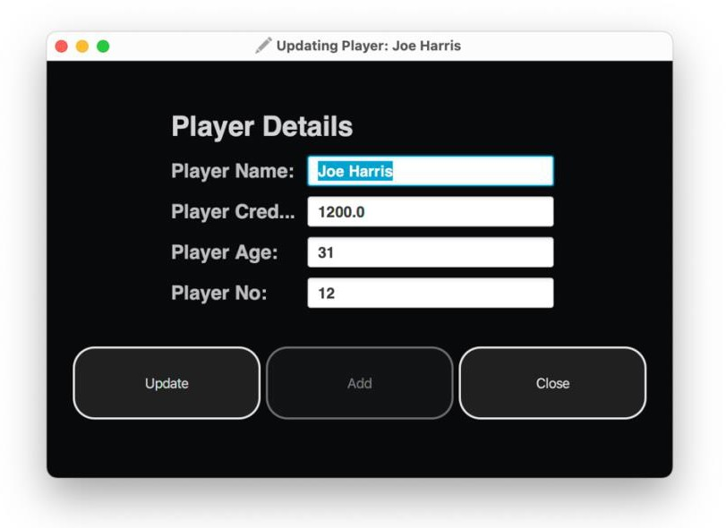

The player update window has buttons to update the player’s information and has close button to close the player update window. Only "Update" and "Close" buttons are enabled.

Update button opens the error window when the input is not valid. The button closed the window when the input is valid or there is not input. The input validation is described in validator.java and associated with the error window. Meanwhile, team manage window immediately updates the player’s information.

The player update window includes an “edit” icon. The title of the window is “Updating Player: ” plus the name of the player.

# Add a Player

The player update window (PlayerUpdateView.fxml) is also launched from the team manage window by clicking “Add”. When adding a new player, the window displays the empty name and default values, waiting for the input of “Player Details” for a new added player. The title of the window is “Adding New Player”.

The player update window has buttons to add and update player’s information and has close button to close the player update window. Only "Add" and "Close" buttons are enabled.

Add button opens the error window when the input is not valid. Add button closed the window when the input is valid. The input validation is described in validator.java and associated with the error window. Meanwhile, team manage window immediately updates the player’s information.

# Error Window

The error window is popped up when the input is not valid. The error window displays the input error messages based on the input validation described in validator.java.

* Name Pattern: First name and Last name are two strings with capital letters.
* Number Pattern: any positive integer
* Decimal Pattern: any decimal number (- or +)

The error window has “Okay” button to close the window. The title of the window includes an “error” icon and the name is subject to the launched window.

* Adding New Team/ Team Manage window: Error!
* Player Update Window: Input Errors!

# Players Window

The players window (PlayersView.fxml) is launched from the team menu by clicking “View Players”. The players window displays all players information in a table view. There are six columns, “Team”, “Player Name”, “Player credit”, “Player Age”, “Player No”, “Player Level”. The table can be sorted by each of the column and the selected players will be highlighted in blue. The default setting is to sort ascended by “Team”.

The players window has “Close” button to close the window. The title of the window includes an “NBA” icon, and the name is “Players”.

On the bottom of the players window, there are three filters, which display the players with matched name, or level or age. The filters work collaboratively with non-case sensitive partial matching function. For example:

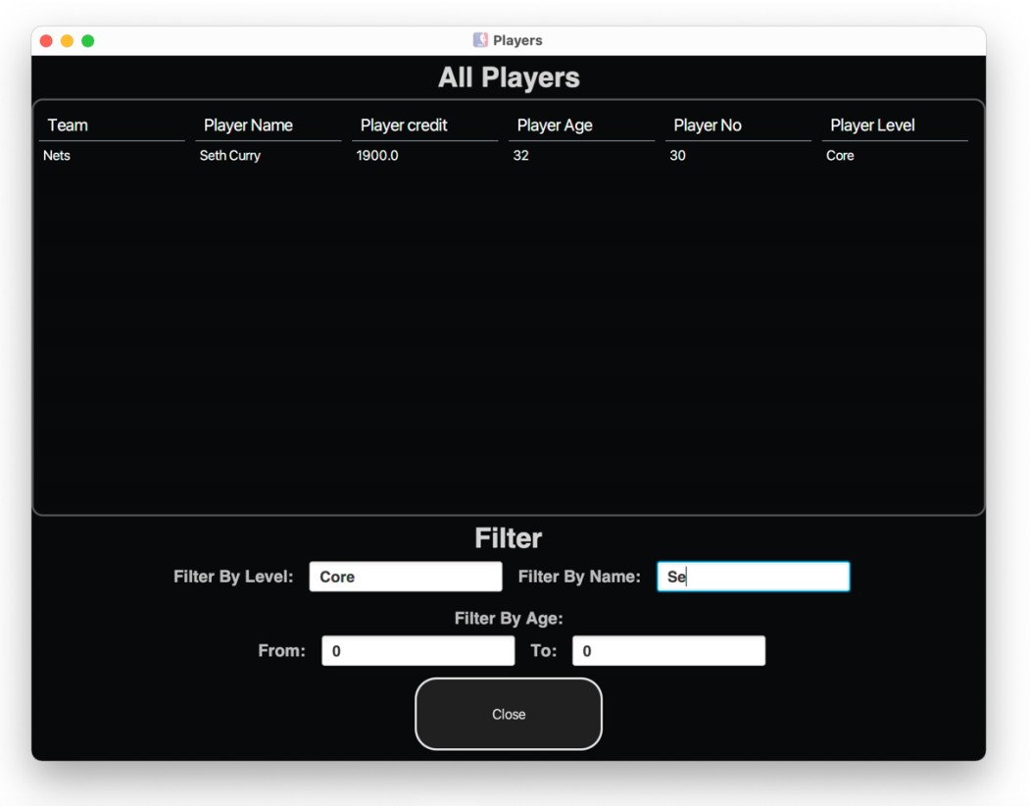

When the Name filter is set with “se”, the players window displays the player list based on the matched records in the level filter result of “The players window prints "Players list is not loaded" when there is no matches result.

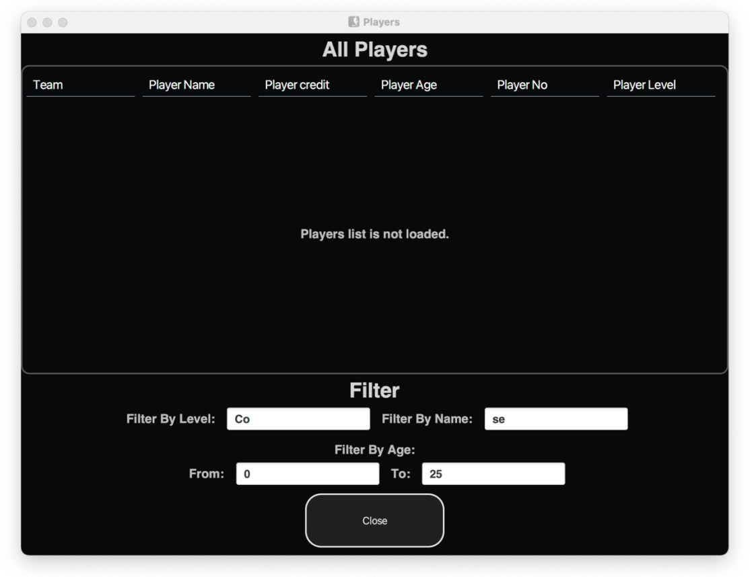

# Season Round Window

The season round window (SeasonRoundView.fxml) is launched from the season menu by clicking “Round”. The title of the window includes an “NBA” icon and the name is “Season Rounds”. The season round window contains one team list, one game table and two buttons. The initial view is titled with “Round: 1” and has four teams in the left list (Suns, Bulls, Hawks, Nets). The buttons “>>>” and “Arrange Season” are disabled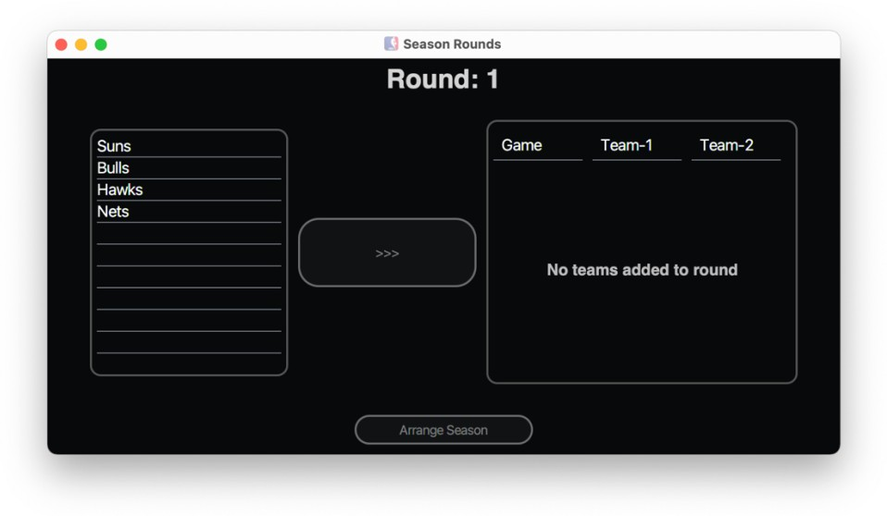.The “>>>” button will be enabled only when two teams are selected in the list. By clicking “>>>”, the two teams will be added to the game table.

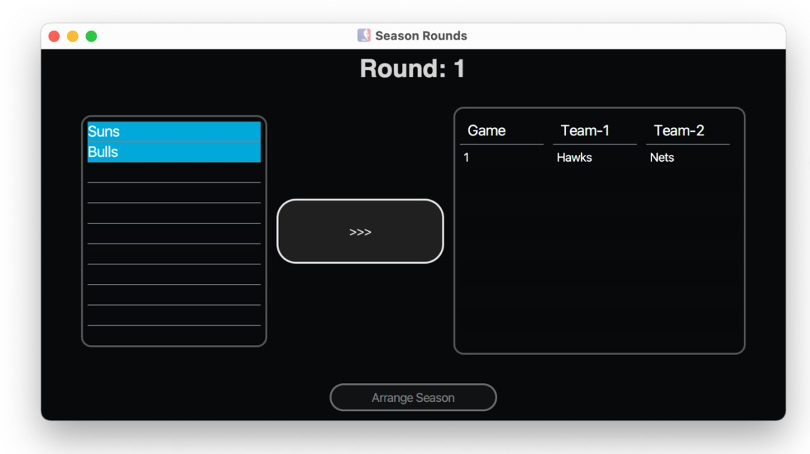

The “Arrange Season” button will be enabled only when all the teams in the list are added to the game table. The empty team list will display “All teams added to round” and the “>>>” button is disabled.

Clicking ”Arrange Season” confirms the season round teams and closes the season round window.

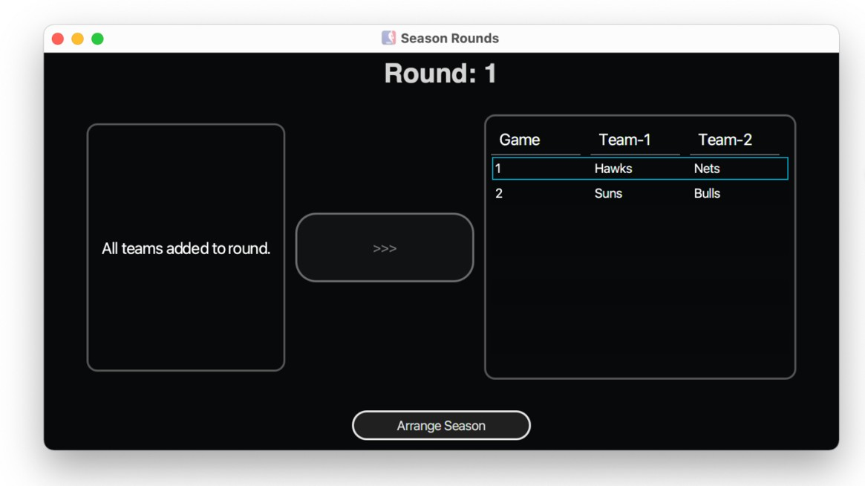

# Current Round Teams Window

The current round teams window (CurrentRoundTeams.fxml) is launched from the season menu by clicking “Current”. The title of the window includes an “NBA” icon and the name is “Tournament”. The current round teams window contains one teams table and one “Close” button. The table view is titled with “Round: 1” and displays the teams’ pairs with “VS” in the separation column. The Round number and the teams’ pairs will be updated after each round. The “Close” button closes the current window.

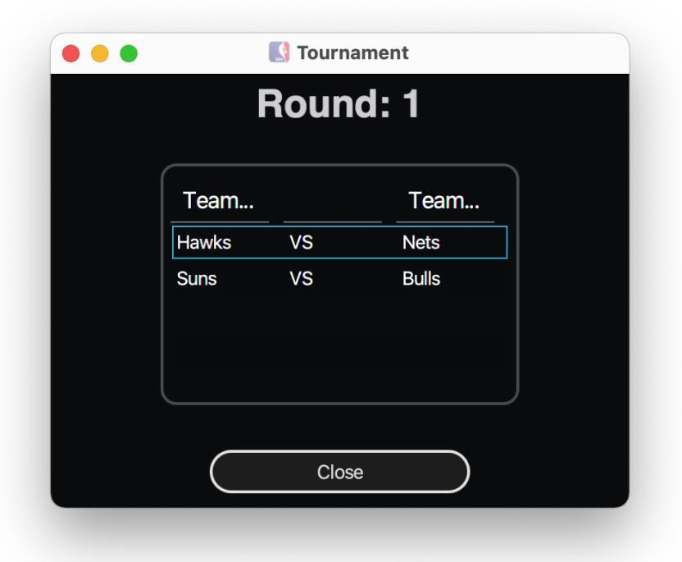

# Game Window

The game window is launched from the season menu by clicking “Game”. The game window shares the view of error window (error.fxml). The title of the window includes an “NBA” icon and the name is “All Games Played!”. The “Okay” button closes the game window.

When no teams are added to the round, the game window displays the message “No Games to play! Please add games to this round.” When the season completes with all the rounds, the game window displays the message “All games finished! You can check results now! This season ends! Suns is the Champion!!”

|  |  |
| --- | --- |
|  |  |

When the season has been arranged with the first round, the game window displays the message “All games finished! You can check results now!”

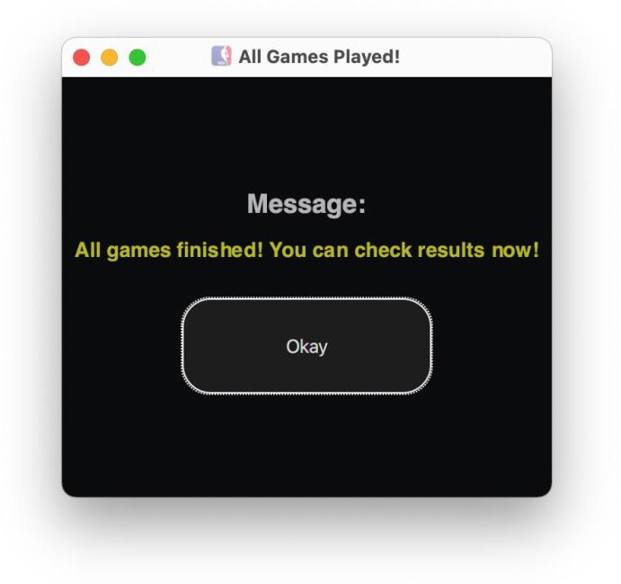

The round number in season round window and current round teams window will increase by 1. Meanwhile, the winning teams in the first round will be added to the team list in season round window.

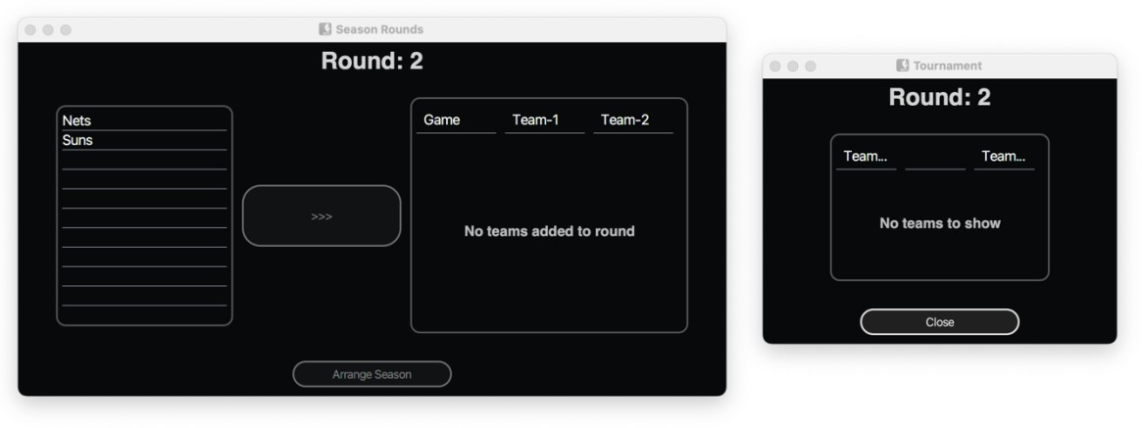

# Record Window

The record window (RecordView.fxml) is launched from the season menu by clicking “Result”. The title of the window includes an “NBA” icon and the name is “Season Record”.

The record window contains one result table and one “Close” button. The table view is titled with “Season Record” and displays the game result in each round for each pair. There are four columns in the table “Round”, “Game”, “Winning Team” and “Losing Team”. The result table will be updated each time when “Game” button is clicked. The “Close” button closes the record window.

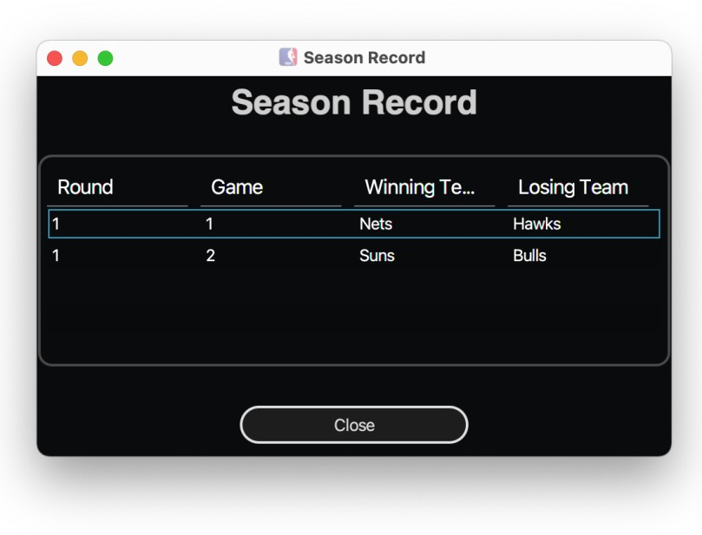

# Requirements

## Layout

You should layout your windows to look as close as possible to the screenshots. This means that you should try to duplicate the spacing between and around nodes that is shown in the screenshots, and the width and height of the nodes, and the alignment of the nodes.

## Style

A CSS file is included in the skeleton code which provides all the styles used in the project You don’t need to modify the CSS file.

## Code

Your solution must satisfy the following code requirements:

* Your solution must follow the MVC architecture and utilize multiple window display.
* Your solution must keep the package structure and class names that were provided in the skeleton code.
* For JavaFX, the models must notify the views of changes by correctly applying the JavaFX property patterns and observable lists. Model data that can change must be observable. Model data that never changes need not be observable.
* For JavaFX, the views must be laid out in FXML.